RIPHAH INTERNATIONAL UNIVERSITY


Faculty of Computing
Object Oriented Programming Lab
Lab 9
Abstraction
Submitted By: Khadija Binte Asif
SAP ID: 77954
Submitted To: Miss Nayab Khalid

Lab Manual Development Team

Supervision and Coordination

Hira Jaffar
Lecturer
Faculty of Computing

Lab Designers
Nayab Khalid Kayani
Lecturer
Faculty of Computing

Lab 10: Abstraction
Lab Exercises:
Task 1:
You are tasked with designing a transportation system using Object-Oriented Programming (OOP) principles in Java.
- Abstract Class: Transport
  - Define an abstract method move() to represent the movement behavior of different transport types. o Define a concrete method fuelType() that prints "Uses fuel or electricity."
- Concrete Subclasses:
  - Create a subclass Train that extends Transport:
    - Implement the move() method to print "Train runs on tracks." o Create another subclass Airplane that extends Transport:
    - Implement the move() method to print "Airplane flies in the sky."
- Main Method:
  - In the Main class:
    - Create polymorphic references of type Transport for both Train and Airplane.
    - Call move() and fuelType() methods for each object to demonstrate polymorphism and method overriding.

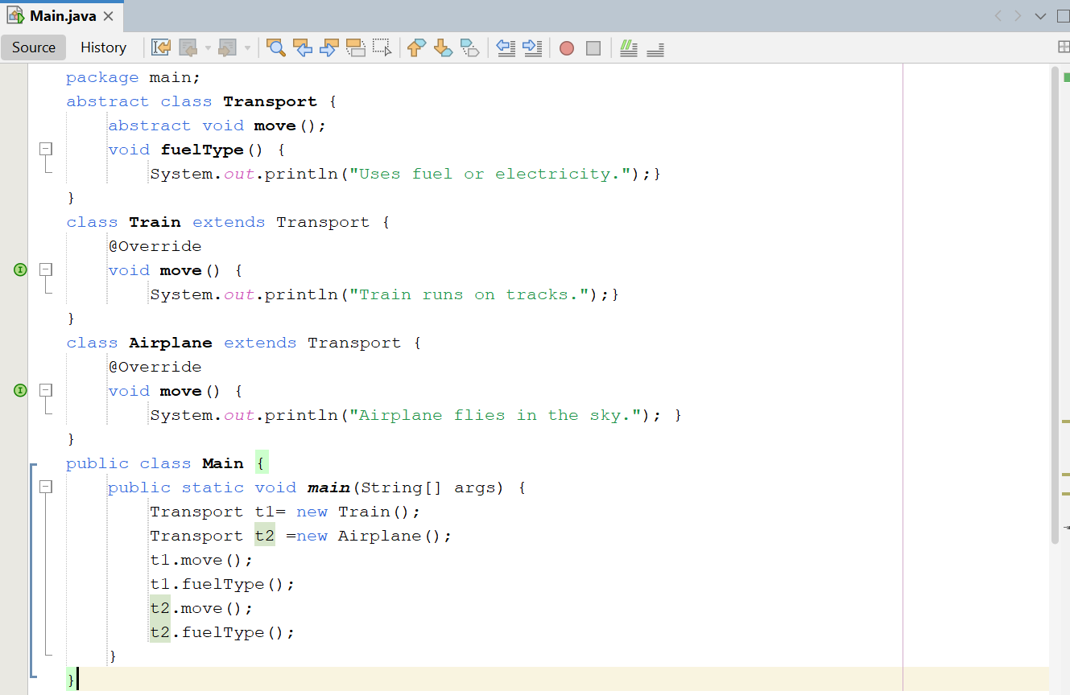

Output:
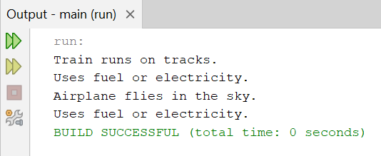
Task 2:
Create an interface named PaymentGateway:
- Declare a method makePayment(double amount).
Implement at least three payment types as classes:
- CreditCardPayment
- PayPalPayment
- UPIPayment
- Each class should implement PaymentGateway and define custom logic for makePayment() (e.g., print a message showing which payment is being processed).
Create a Main class to test your implementation:
- Use polymorphism by referencing PaymentGateway while creating objects of the specific payment classes.
- Call the makePayment() method for each payment type using different objects.
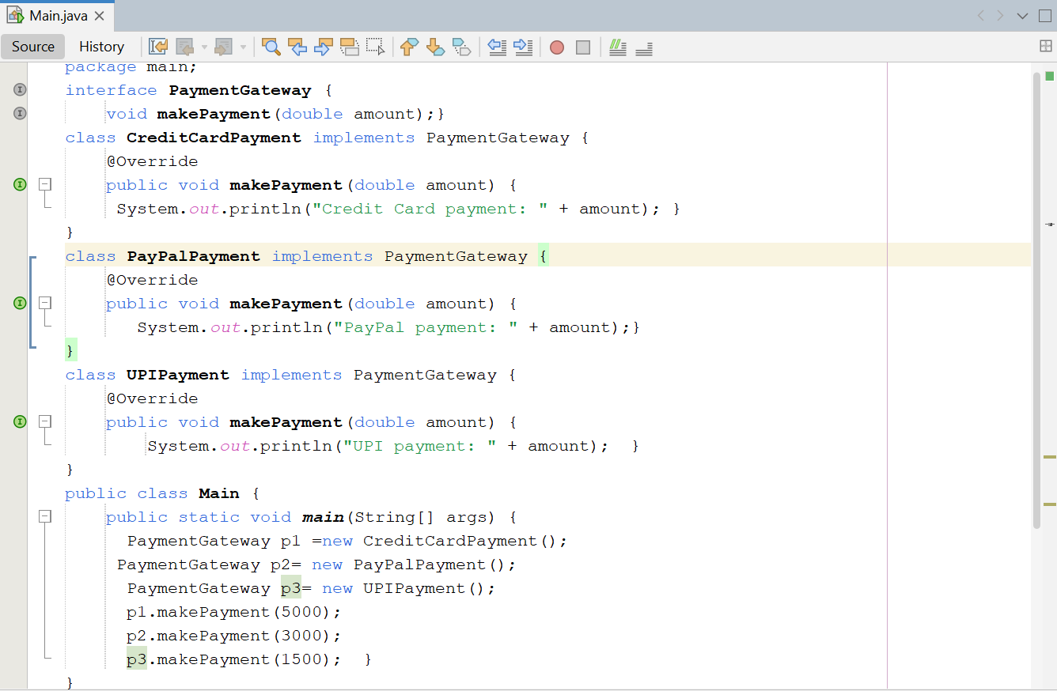
Output:


